NAME : Manasseh. M
Topic : Data Analyst

Task: Statistical Analysis and Predictive Modeling using R

INTRODUCTION
This task focuses on performing statistical analysis and developing a predictive model using R programming. The Titanic dataset was selected because it contains a combination of numerical and categorical variables and includes a clear target variable, Survived.
The objective of the predictive model is to predict whether a passenger survived based on variables such as passenger class, gender, age, family information, and ticket fare. Before building the model, exploratory statistical analysis, correlation analysis, and hypothesis testing were performed.
A Logistic Regression model was developed because the target variable contains two possible outcomes: survived and not survived. The dataset was divided into training and testing data, and the model was evaluated using predictions, a confusion matrix, and accuracy metrics.

2. DATASET IDENTIFICATION
Dataset Name: Titanic Dataset
Reason for Choosing the Dataset:
The Titanic dataset was selected because it is suitable for classification and predictive modeling. It contains both numerical and categorical variables and has a binary target variable called Survived.
R Code:
titanic_data <- read.csv("Titanic-Dataset.csv")
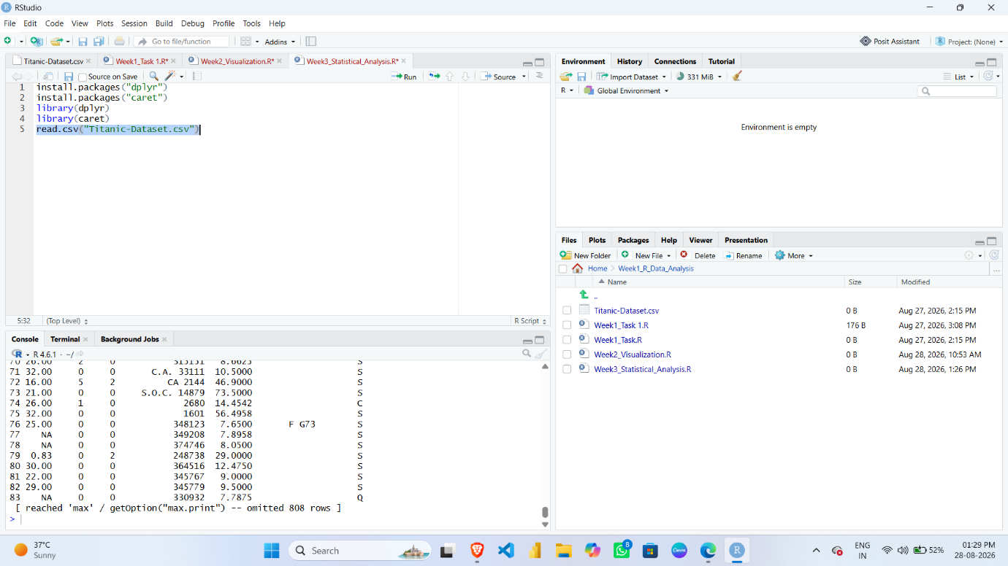

head(titanic_data)
dim(titanic_data)
str(titanic_data)

Screenshot:
head(titanic_data)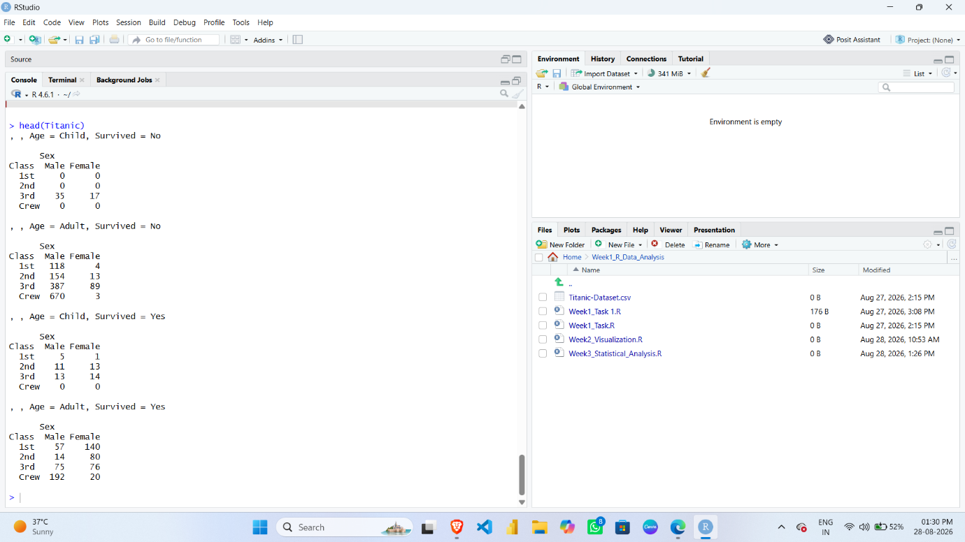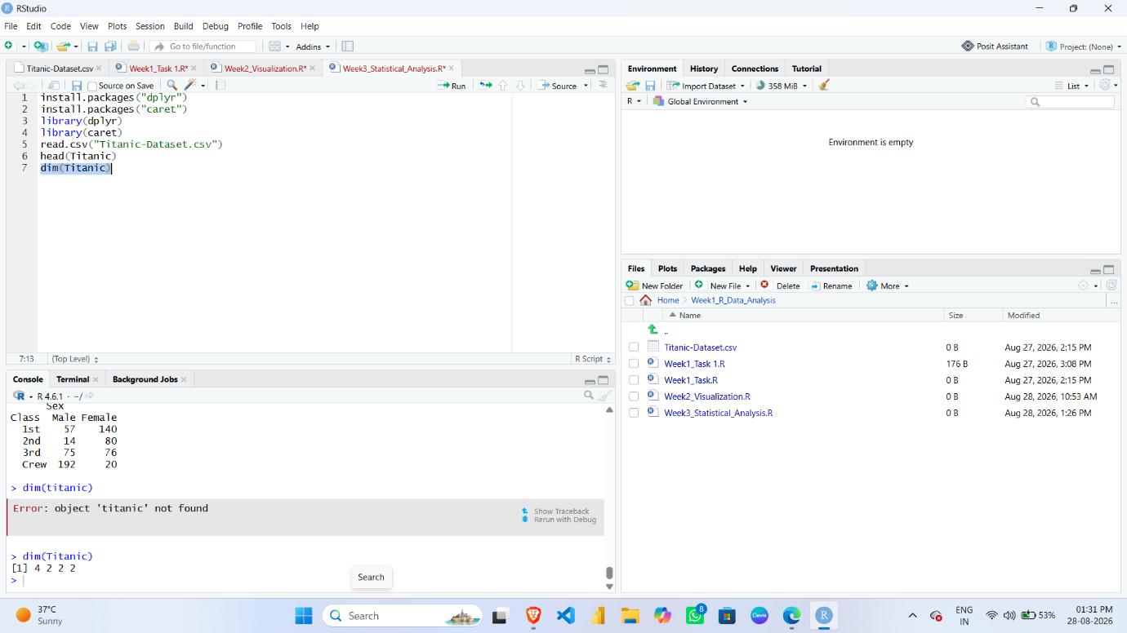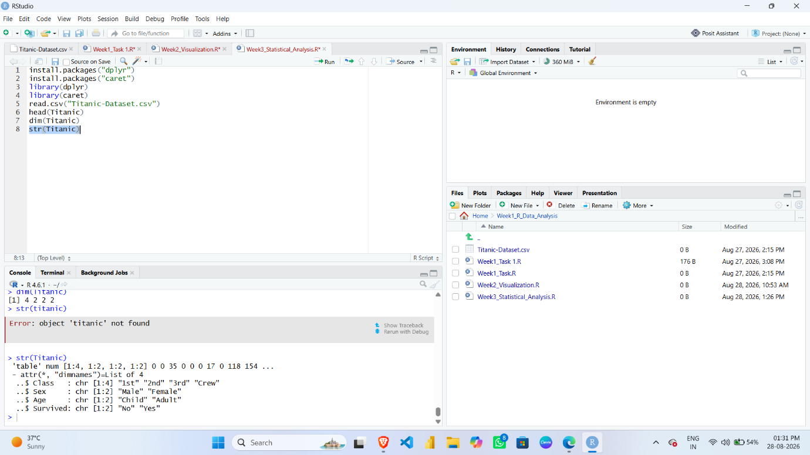

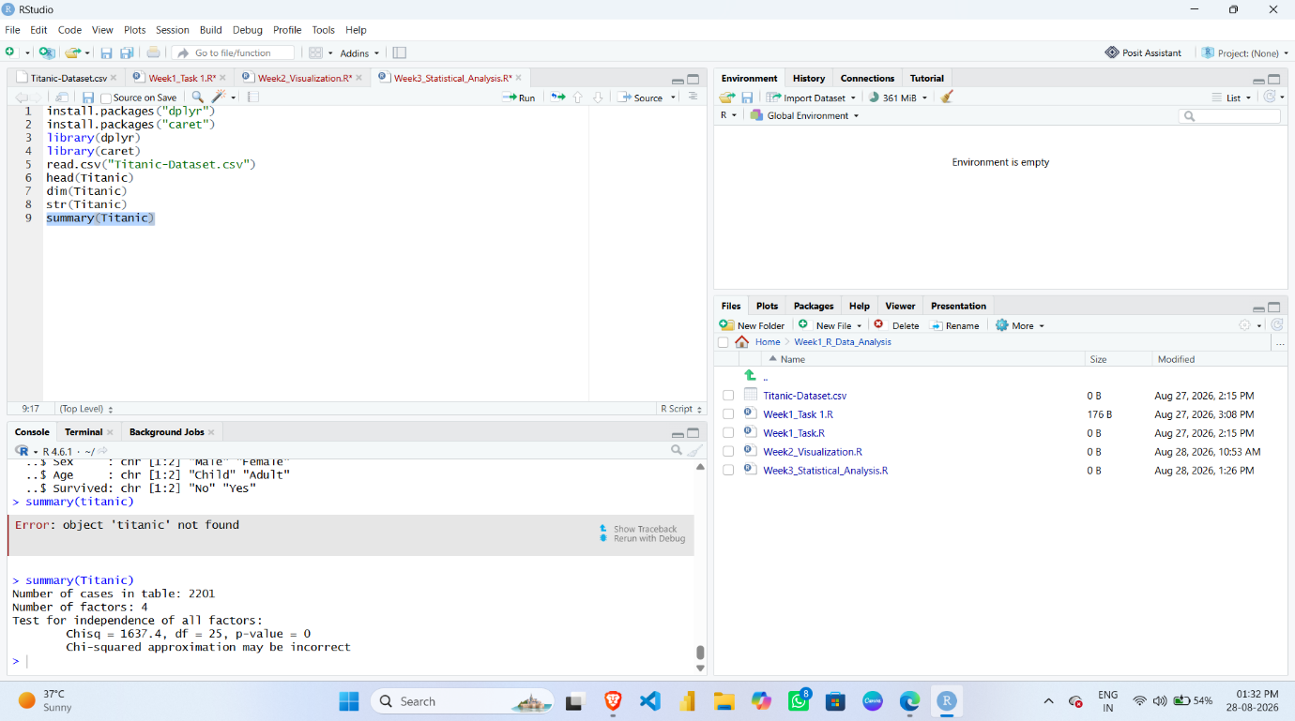

DATA PREPARATION
Missing values were checked before statistical analysis and model building.
R Code:
colSums(is.na(titanic_data))
Screenshot:
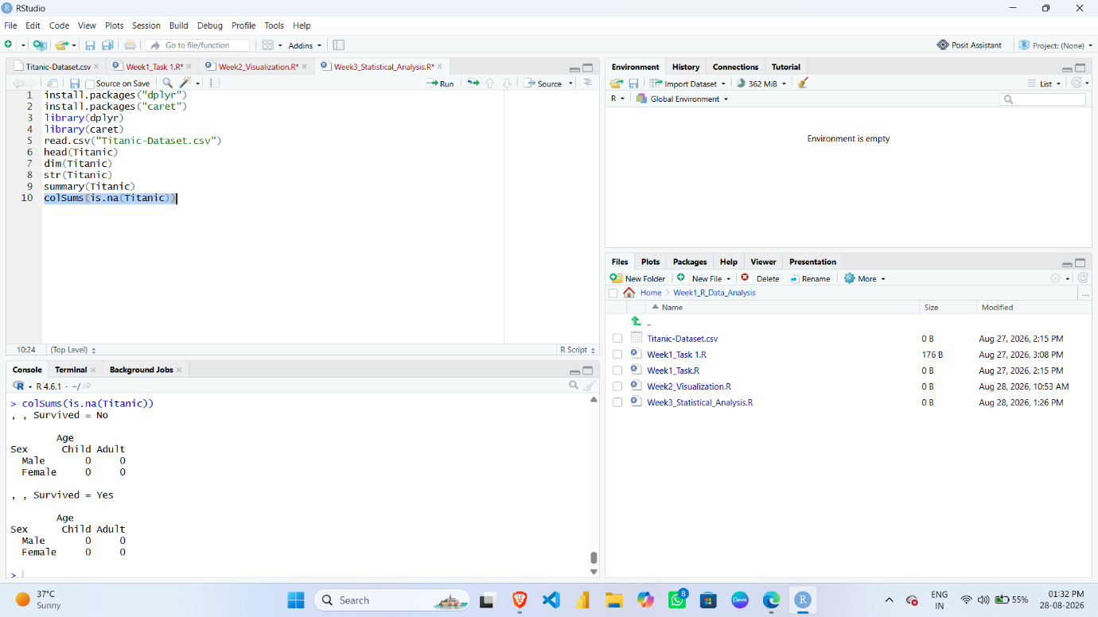

3.1 Handling Age Missing Values
R Code:
titanic_data$Age[is.na(titanic_data$Age)] <-
median(titanic_data$Age, na.rm = TRUE)
Screenshot:
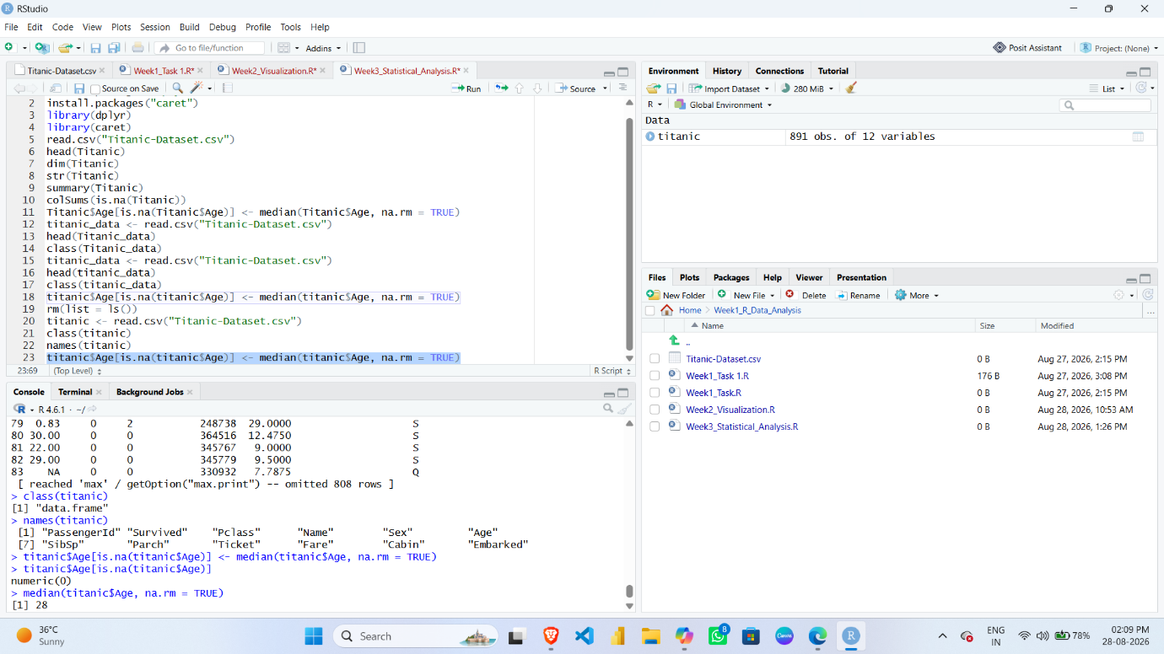

4. EXPLORATORY STATISTICAL ANALYSIS
4.1 Summary Statistics
R Code:
summary(titanic_data)

Screenshot:
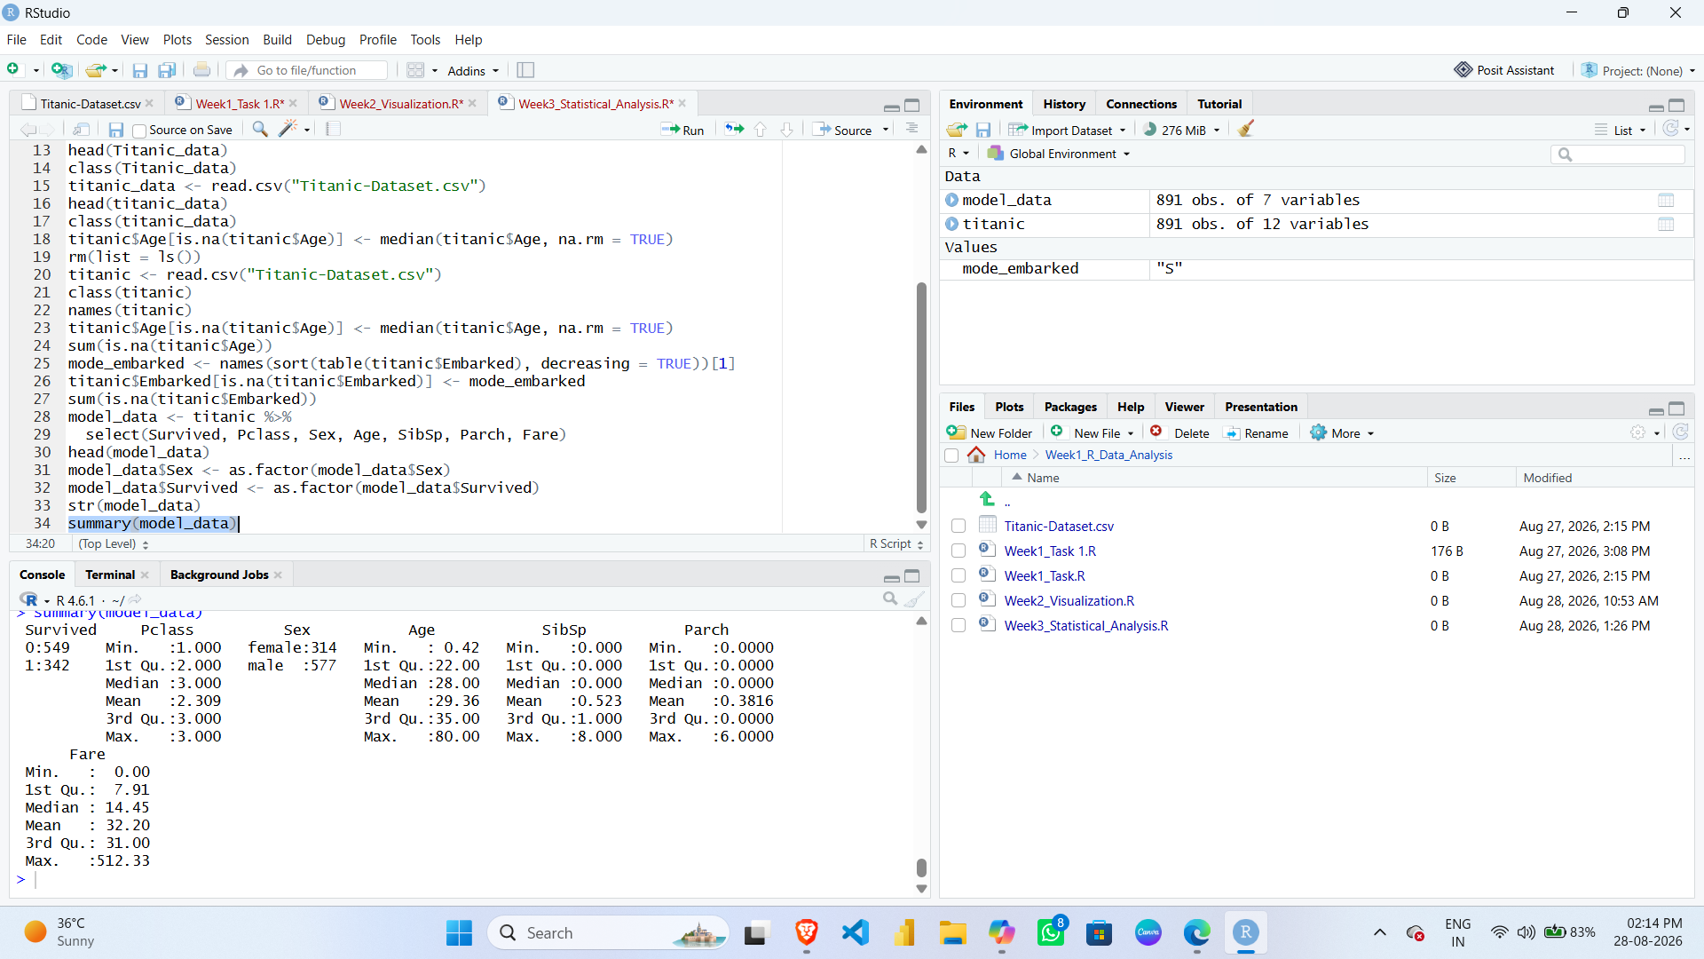
Interpretation:
Summary statistics provide information about the minimum, maximum, median, mean, and distribution of the variables.

5. CORRELATION ANALYSIS
Correlation analysis was performed to examine relationships between numerical variables.
R Code:
numeric_data <- titanic_data[, c("Pclass", "Age", "SibSp", "Parch", "Fare")]

cor(numeric_data)

Screenshot:
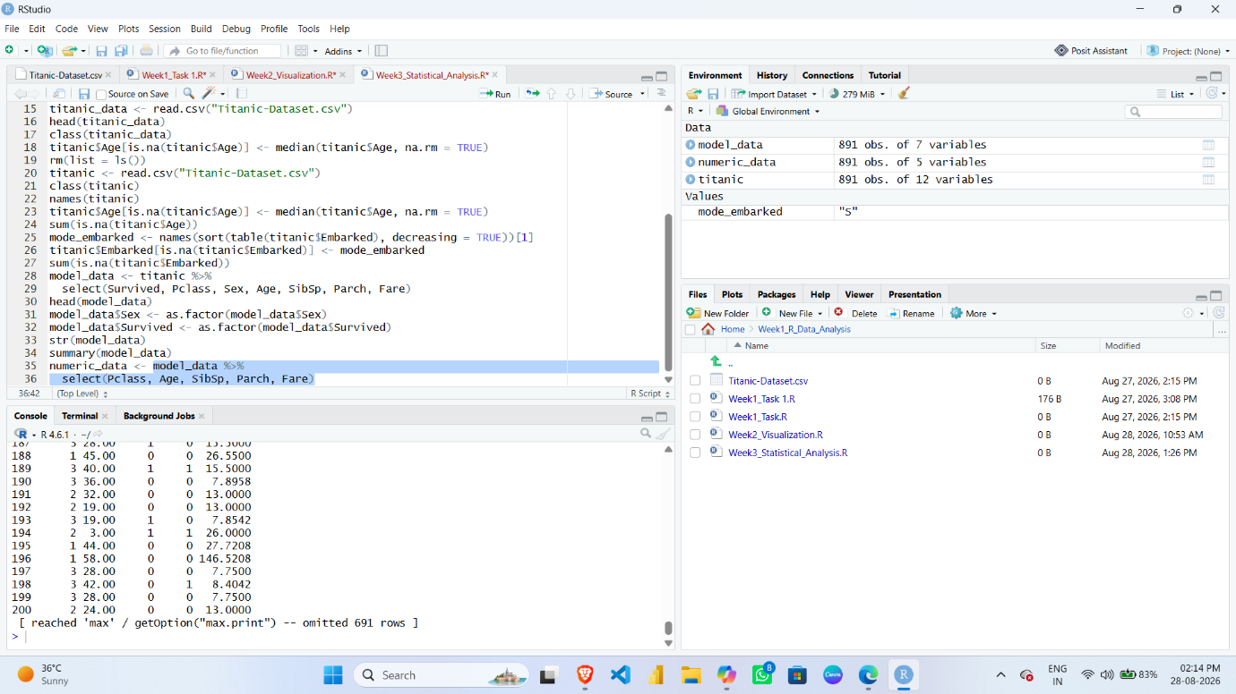
6. HYPOTHESIS TESTING
Null Hypothesis (H₀)
There is no significant association between gender and survival.
Alternative Hypothesis (H₁)
There is a significant association between gender and survival.
A Chi-Square Test was used to test the relationship between gender and survival status.
R Code:
survival_gender <- table(
titanic_data$Sex,
titanic_data$Survived
)

chisq.test(survival_gender)
Screenshot: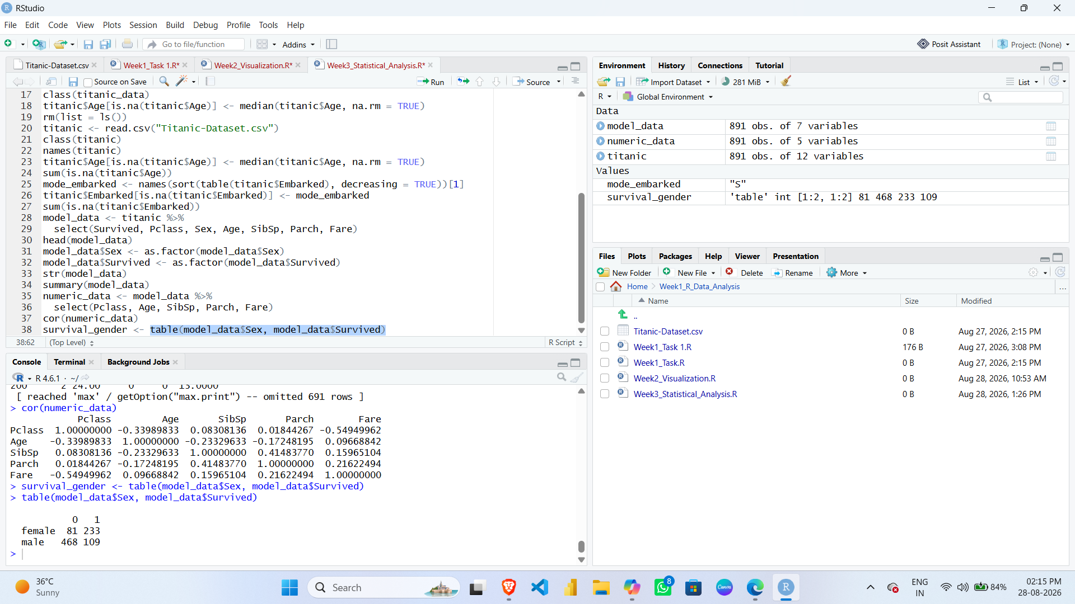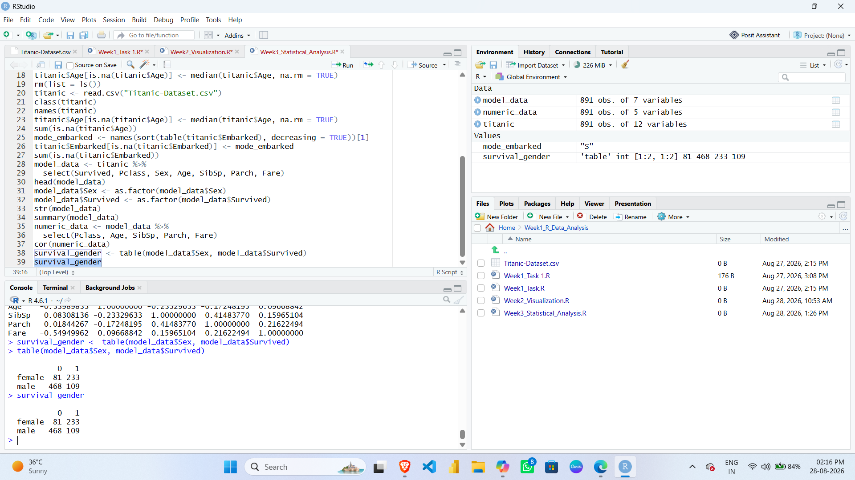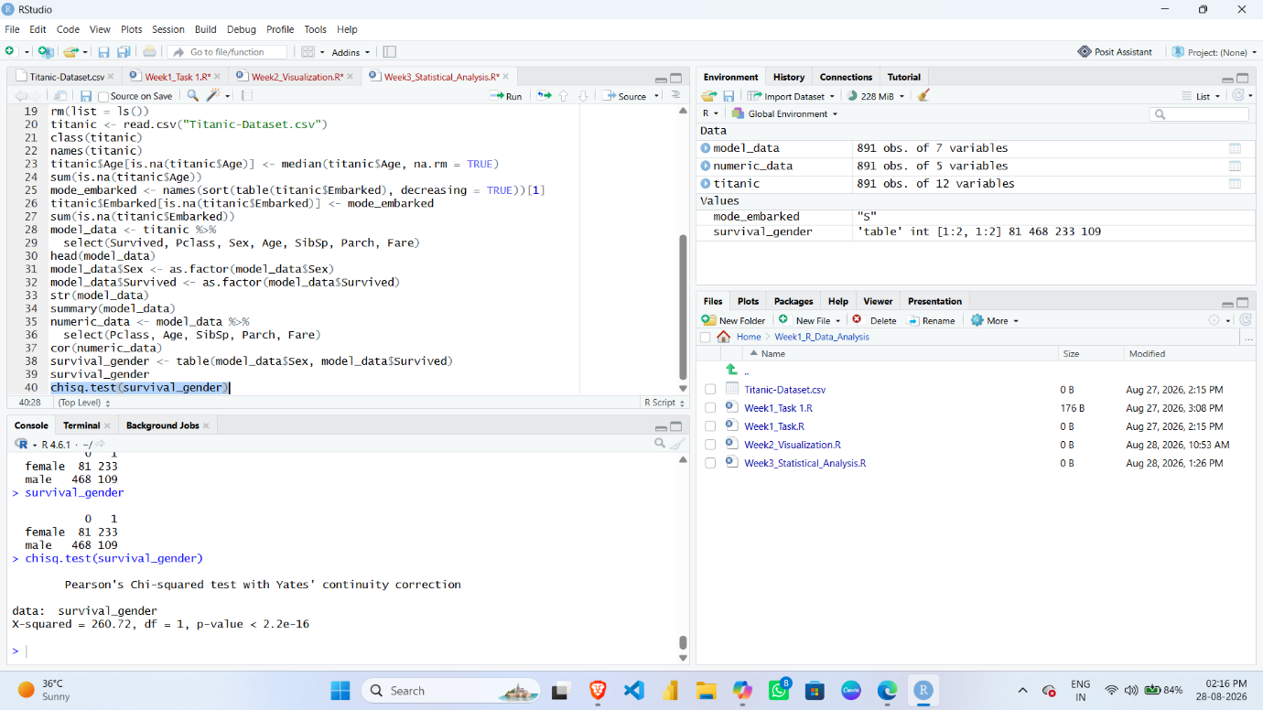
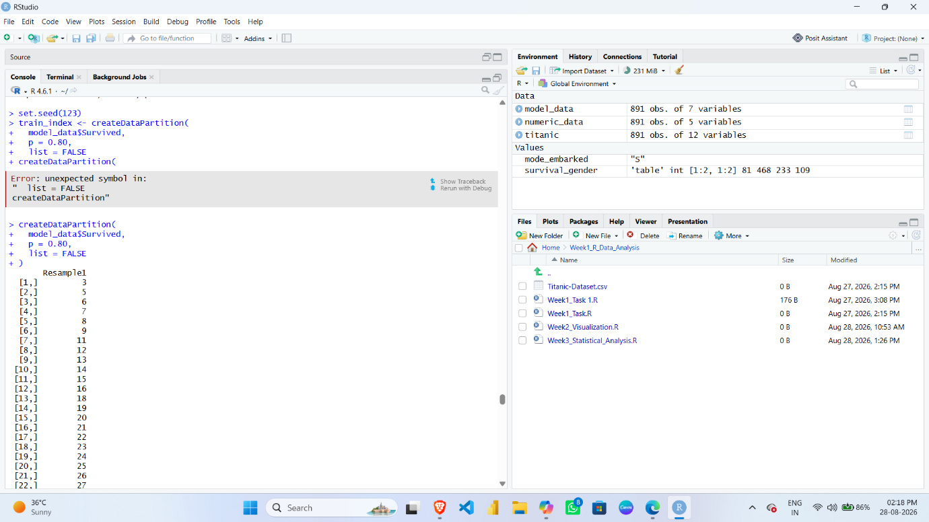
7. MODEL BUILDING
A Logistic Regression classification model was developed to predict passenger survival.
Target Variable:
Survived
Input Variables:
- Pclass
- Sex
- Age
- SibSp
- Parch
- Fare

7.1 Selecting Model Variables
R Code:
model_data <- titanic_data %>%
select(Survived, Pclass, Sex, Age, SibSp, Parch, Fare)
Screenshot:
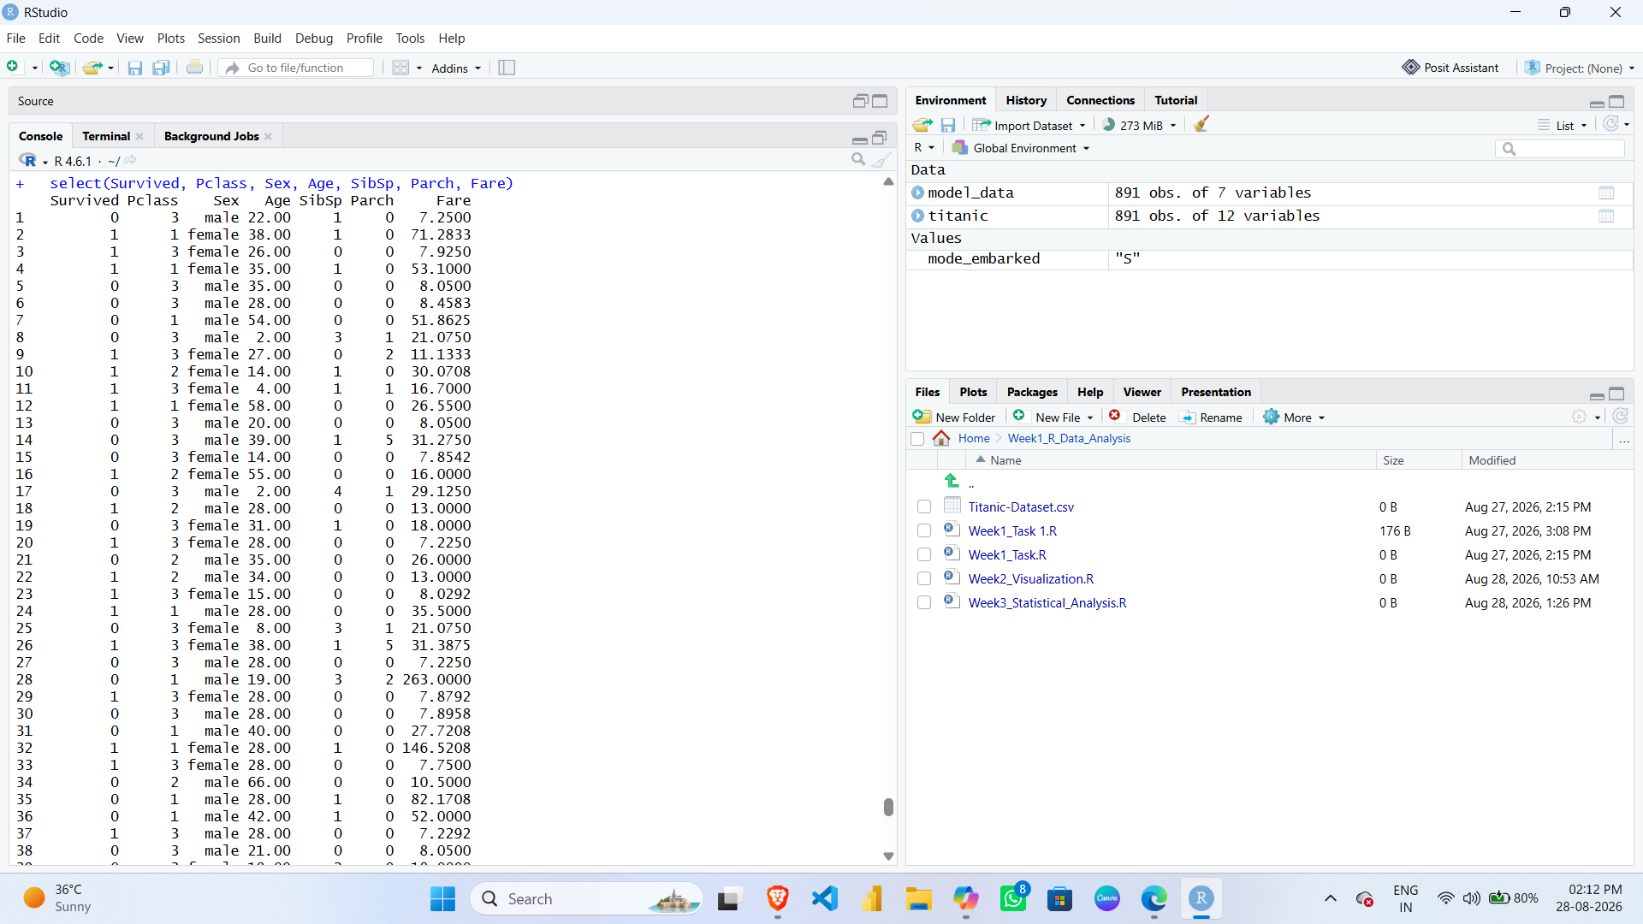

8. TRAINING AND TESTING DATA SPLIT
The dataset was divided into:
- 80% Training Data
- 20% Testing Data
R Code:
set.seed(123)
train_index <- createDataPartition(
model_data$Survived,
p = 0.80,
list = FALSE
)
train_data <- model_data[train_index, ]
test_data <- model_data[-train_index, ]
Screenshot:
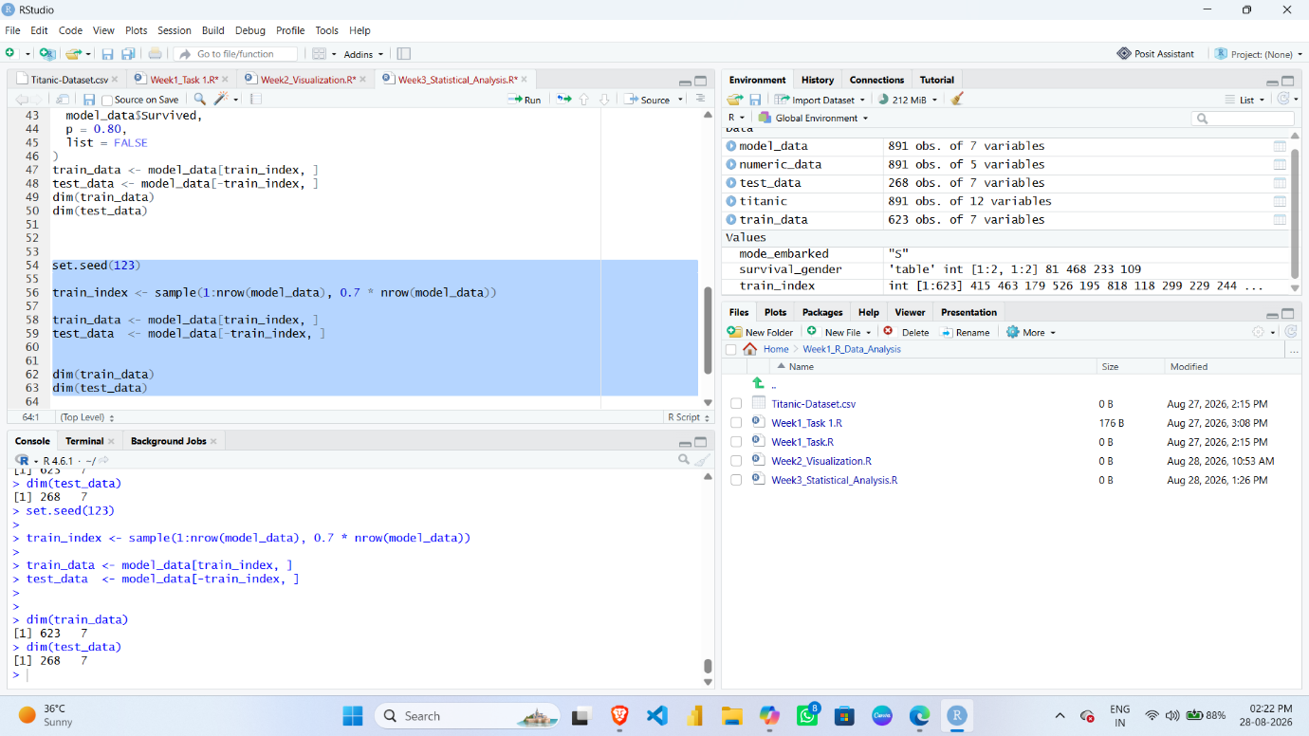
09. PREDICTION
The trained model was used to predict survival outcomes for the testing dataset.
R Code:
predicted_prob <- predict(
model,
test_data,
type = "response”)
predicted_class <- ifelse(
predicted_prob > 0.5,
"1",
"0"
)
Screenshot:
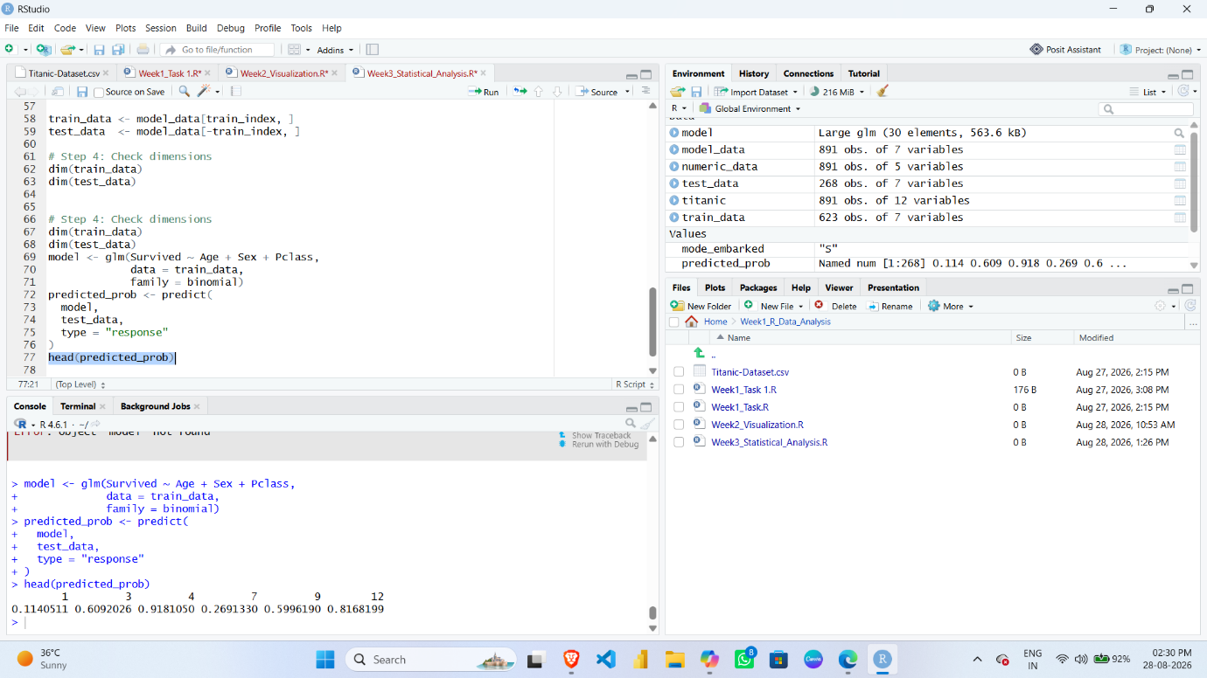
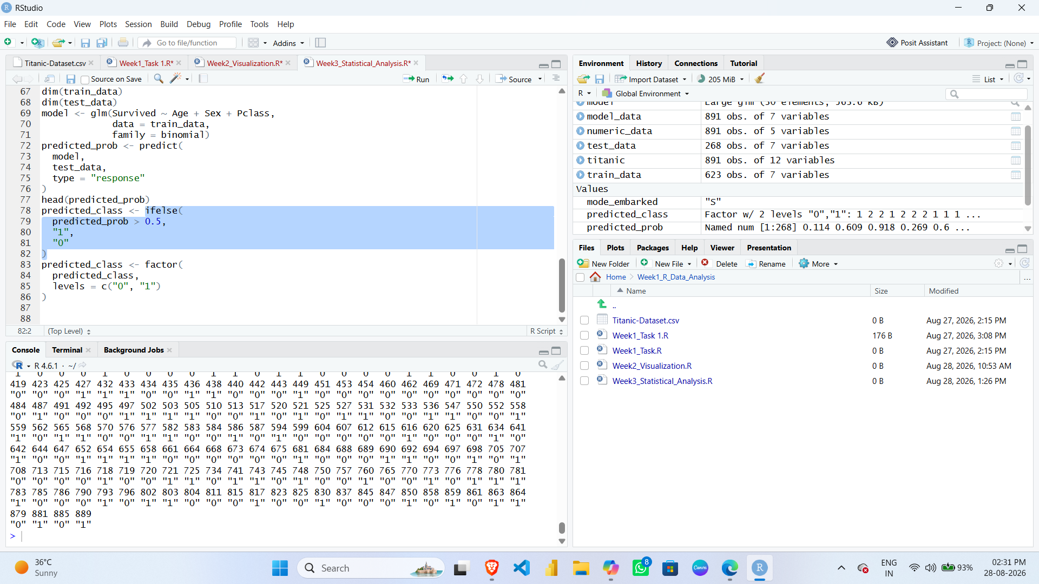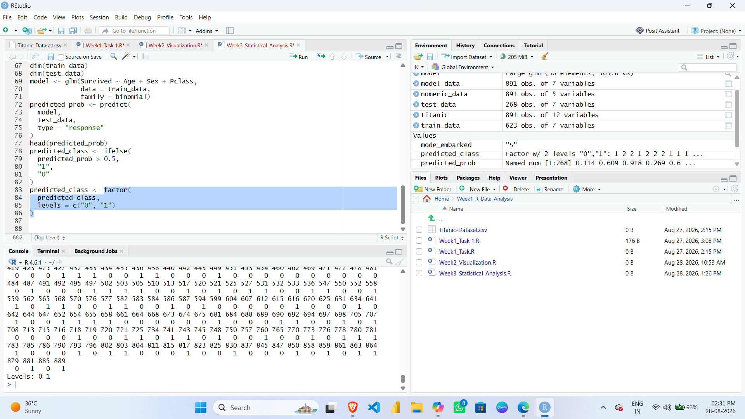
10. MODEL EVALUATION
A confusion matrix was used to evaluate the classification performance of the model.

R Code:
confusionMatrix(
predicted_class,
test_data$Survived
)
Screenshot:
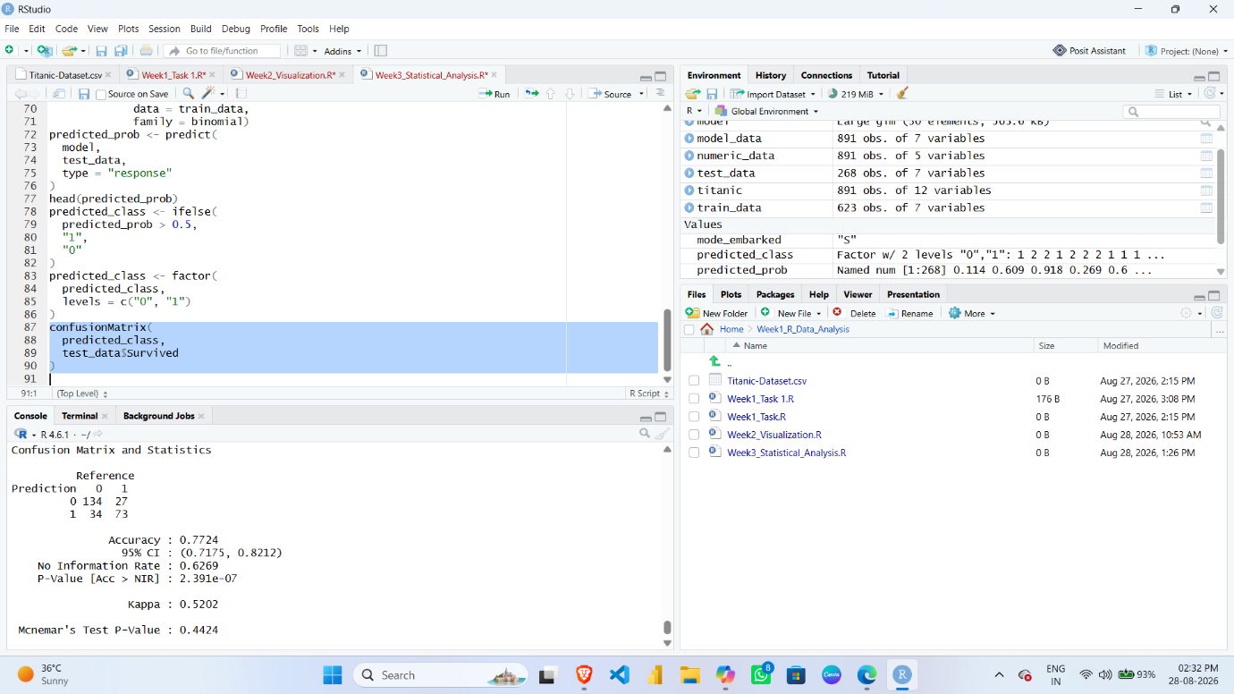

11. ACCURACY
R Code:
mean(predicted_class == test_data$Survived) * 100
Screenshot:
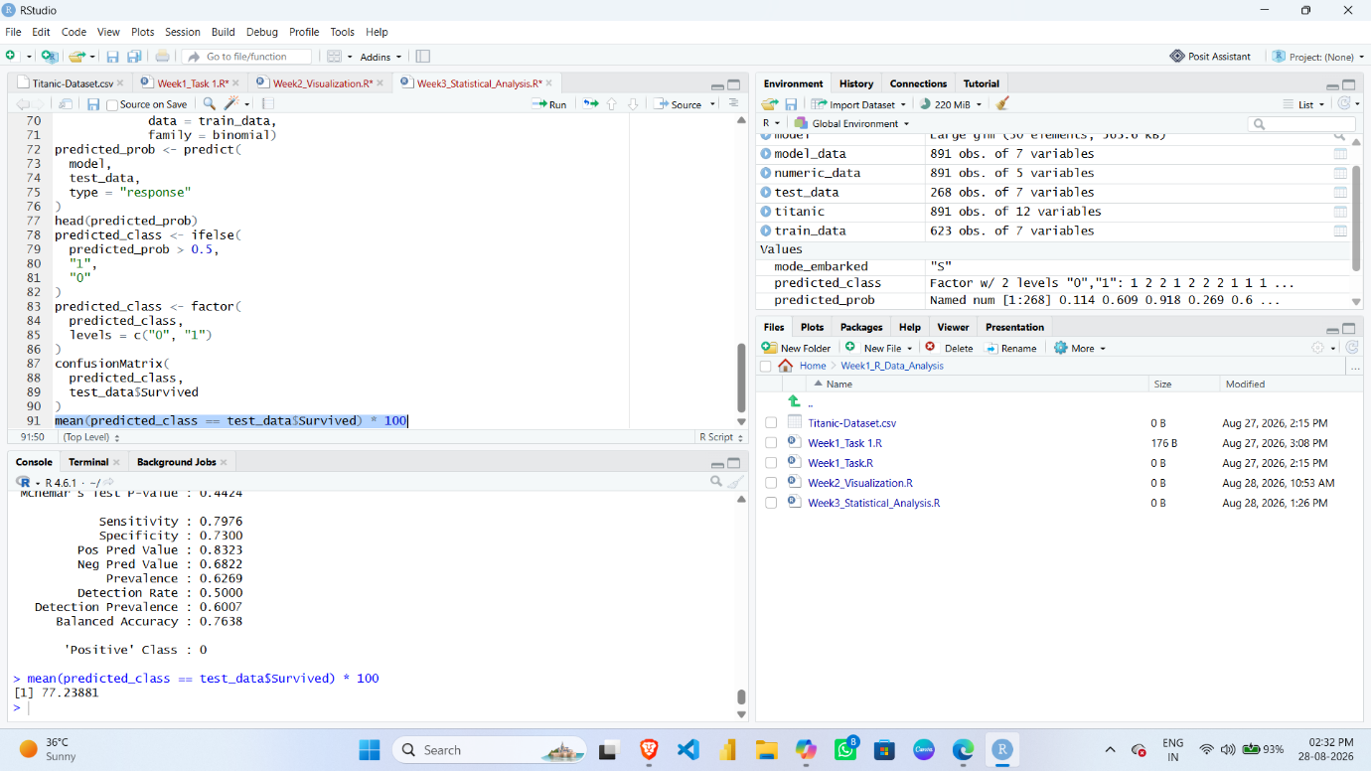
Interpretation:
The accuracy value represents the percentage of correct predictions made by the model.
Important: Write the exact accuracy percentage that appears in your RStudio output.

12. MODEL DIAGNOSTICS
Model diagnostic plots were generated to examine the performance and behavior of the Logistic Regression model.
R Code:
plot(model)
Screenshot: